OOPS ASSIGNMENT
SINGLE INHERITANCE :
#include <iostream>
using namespace std;
class Product
{
public :
string name;
double price;
void getdata()
{
cout<<"Product : "<<endl<< "Price: "<<endl;
cin>>name>>price;
}
void getdisplay()
{
cout<<"Product: "<<name<<" "<<"Price:$"<<price<<endl;
}
};
class Electronics : public Product {
public:
string brand;
void input()
{
cout<<"Brand: "<<endl;
cin>>brand;
}
void display()
{
cout<<"Brand: "<<brand<<endl;
}
};
int main()
{
Electronics laptop;
laptop.getdata();
laptop.getdisplay();
laptop.input();
laptop.display();
return 0;
}
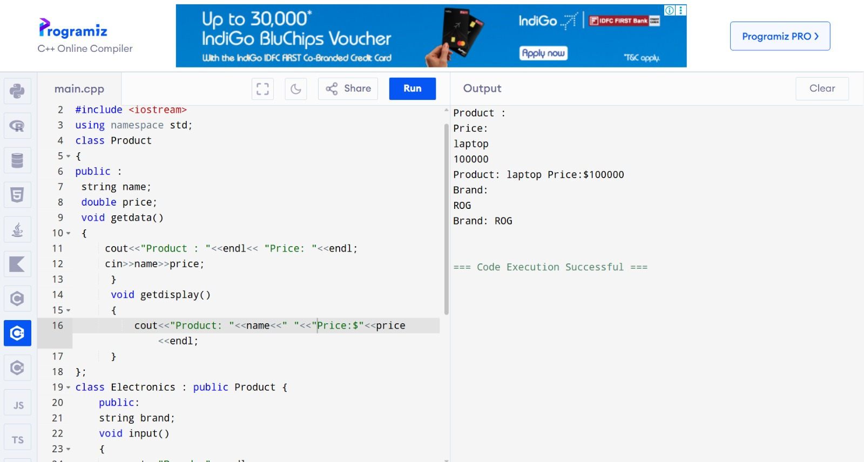

MULTILEVEL INHERITANCE
#include <iostream>
using namespace std;
// Parent class
class Product {
public:
string name;
double price;
void displayProduct() {
cout << "Product: " << name << ", Price: $" << price << endl;
}
};
// Child class
class Electronics : public Product {
public:
string brand;
void displayElectronics() {
displayProduct(); // Call parent method
cout << "Brand: " << brand << endl;
}
};
// Grandchild class
class Smartphone : public Electronics {
public:
string os; // Operating system
void displaySmartphone() {
displayElectronics(); // Call parent method
cout << "Operating System: " << os << endl;
}
};
int main() {
Smartphone phone;
phone.name = "Smartphone";
phone.price = 800;
phone.brand = "Samsung";
phone.os = "Android";
phone.displaySmartphone();
return 0;
}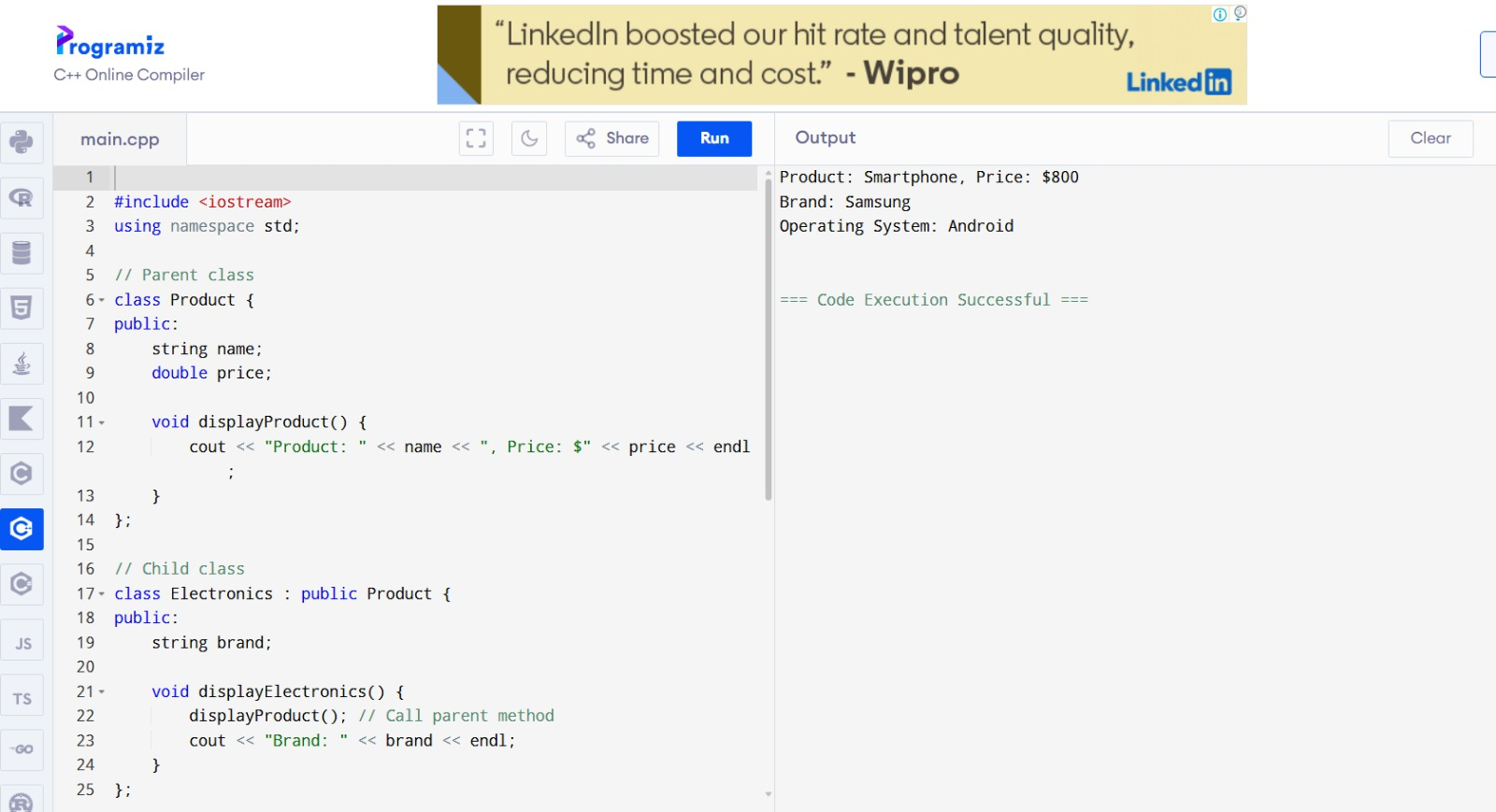
MULTIPLE INHERITANCE
#include <iostream>
using namespace std;

// Parent class 1
class Product {
public:
string name;
double price;

void displayProduct() {
cout << "Product: " << name << ", Price: $" << price << endl;
}
};

// Parent class 2
class Discount {
public:
double discountPercent;

void displayDiscount() {
cout << "Discount: " << discountPercent << "%\n";
}
};

// Child class (Multiple Inheritance)
class Electronics : public Product, public Discount {
public:
string brand;

void displayDetails() {
displayProduct(); // From Product
cout << "Brand: " << brand << endl;
displayDiscount(); // From Discount
}
};

int main() {
Electronics laptop;
laptop.name = "Laptop";
laptop.price = 1200;
laptop.brand = "Dell";
laptop.discountPercent = 10;

laptop.displayDetails();
return 0;
}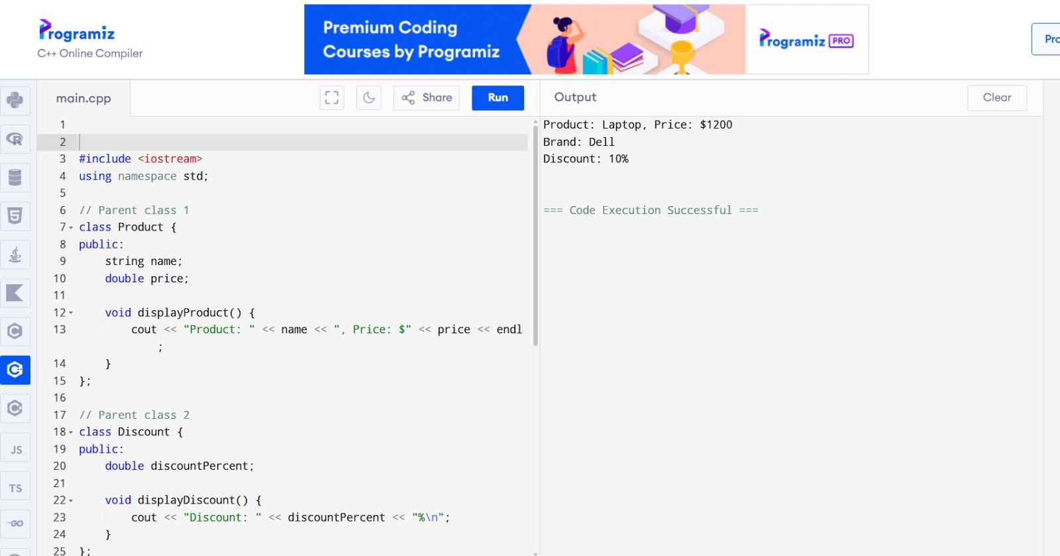
HYBRID INHERITANCE
#include <iostream>
using namespace std;

// Base class
class Account {
protected:
string name;
int accNo;
double balance;

public:
void getData() {
cout << "Enter Name: ";
cin >> name;
cout << "Enter Account Number: ";
cin >> accNo;
cout << "Enter Balance: ";
cin >> balance;
}

void display() {
cout << "\nName: " << name;
cout << "\nAccount Number: " << accNo;
cout << "\nBalance: " << balance << endl;
}
};

// Derived class 1
class SavingsAccount : public Account {
public:
void calculateInterest() {
double interest = balance * 0.05; // 5% interest
cout << "Interest (5%): " << interest << endl;
}
};

// Derived class 2
class CurrentAccount : public Account {
public:
void minimumBalance() {
if (balance < 1000)
cout << "Below Minimum Balance!" << endl;
else
cout << "Minimum Balance Maintained." << endl;
}
};

int main() {
SavingsAccount s;
CurrentAccount c;

cout << "Savings Account Details:\n";
s.getData();
s.display();
s.calculateInterest();

cout << "\nCurrent Account Details:\n";
c.getData();
c.display();
c.minimumBalance();

return 0;
}
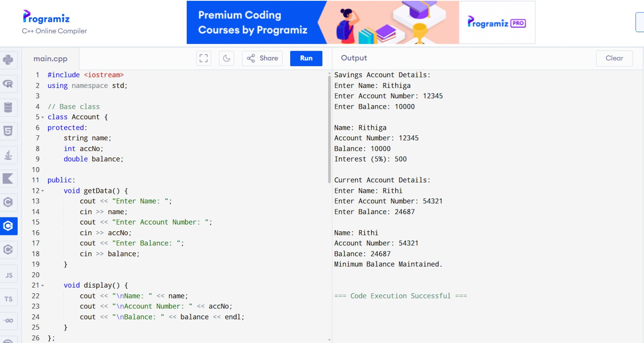
HIERARCHICAL INHERITANCE
#include <iostream>
using namespace std;

// Base class
class Account {
protected:
double balance;
public:
void setBalance(double b) {
balance = b;
}
};

// Derived class 1 (Hierarchical)
class SavingsAccount : public Account {
public:
void showInterest() {
cout << "Interest (5%): " << balance * 0.05 << endl;
}
};

// Derived class 2 (Hierarchical)
class LoanAccount : public Account {
public:
void showLoan() {
cout << "Loan Eligible Amount: " << balance * 2 << endl;
}
};

// Another base class
class Customer {
protected:
string name;
public:
void setName(string n) {
name = n;
}
};

// Hybrid class (Multiple inheritance)
class BankSystem : public SavingsAccount, public Customer {
public:
void display() {
cout << "Customer Name: " << name << endl;
showInterest();
}
};

int main() {
BankSystem b;
b.setName("John");
b.setBalance(1000000);
b.display();

return 0;
}
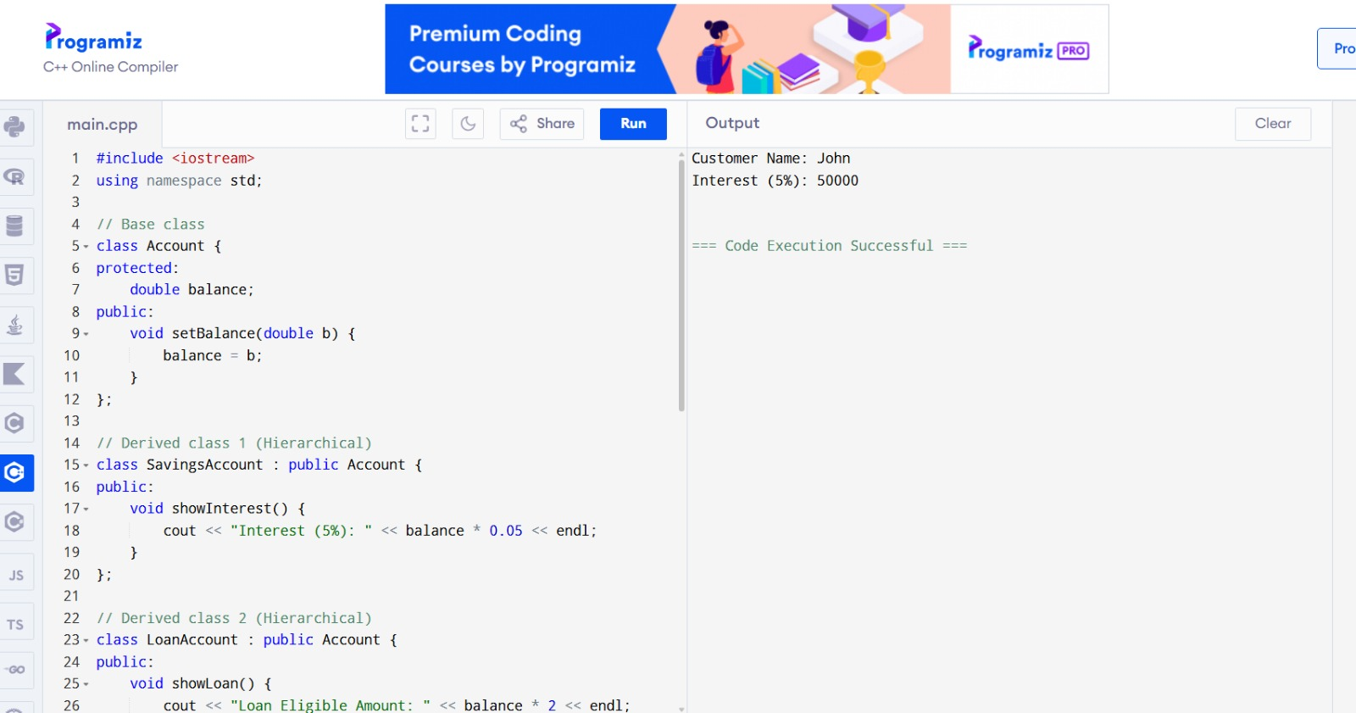
VIRTUAL FUNCTIONS , DYNAMIC BINDING , ABSTACT CLASSES , THIS POINTER
#include <iostream>
using namespace std;

// Abstract class
class Shape {
public:
virtual void area() = 0; // pure virtual
};

// Rectangle class
class Rectangle : public Shape {
int w, h;
public:
Rectangle(int w, int h) { this->w = w; this->h = h; } // this pointer
void area() { cout << "Rectangle area: " << w*h << endl; } // virtual function
};

// Circle class
class Circle : public Shape {
float r;
public:
Circle(float r) { this->r = r; }
void area() { cout << "Circle area: " << 3.14*r*r << endl; }
};

int main() {
int choice;
cout << "1.Rectangle 2.Circle\n";
cin >> choice;

Shape* s; // base class pointer for dynamic binding

if(choice == 1) {
int w,h; cin >> w >> h;
s = new Rectangle(w,h);
} else {
float r; cin >> r;
s = new Circle(r);
}

s->area(); // dynamic binding
delete s;
return 0;
}
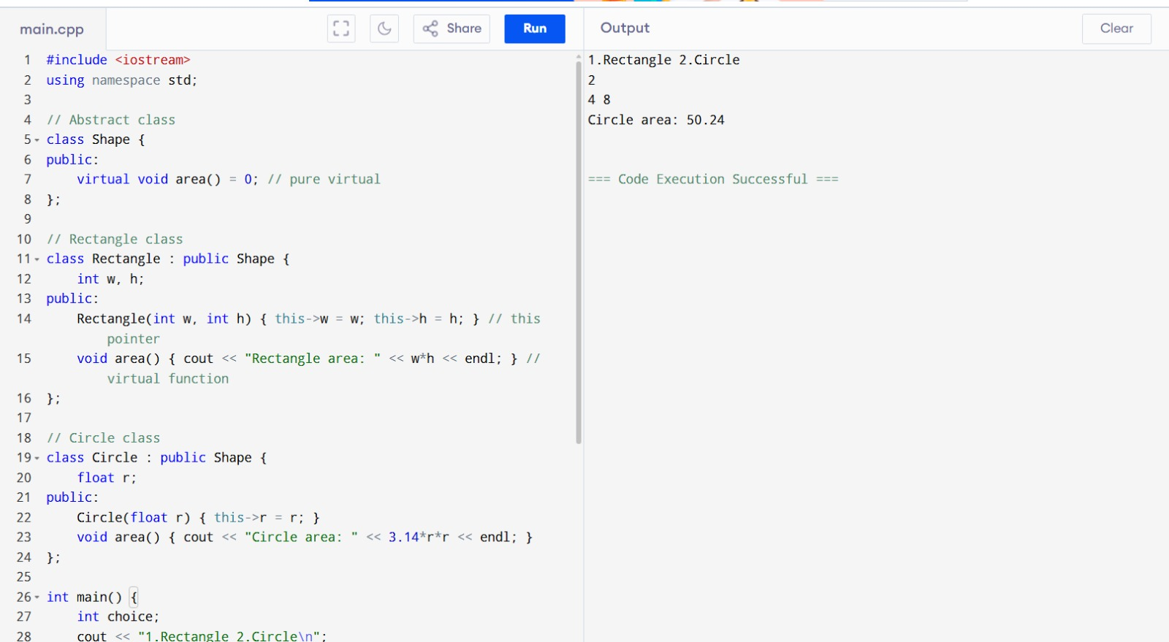

#include <iostream>
using namespace std;

class Vehicle { // abstract class
protected:
string name;
public:
Vehicle(string n) { this->name = n; }
virtual void speed() = 0; // pure virtual
};

class Car : public Vehicle {
int s;
public:
Car(string n, int s) : Vehicle(n) { this->s = s; }
void speed() { cout << name << " speed: " << s << " km/h\n"; }
};

class Bike : public Vehicle {
int s;
public:
Bike(string n, int s) : Vehicle(n) { this->s = s; }
void speed() { cout << name << " speed: " << s << " km/h\n"; }
};

int main() {
int choice, s; string n;
cout << "1.Car 2.Bike\n"; cin >> choice;
cin >> n >> s;

Vehicle* v;
if(choice==1) v = new Car(n,s);
else v = new Bike(n,s);

v->speed(); // dynamic binding
delete v;
}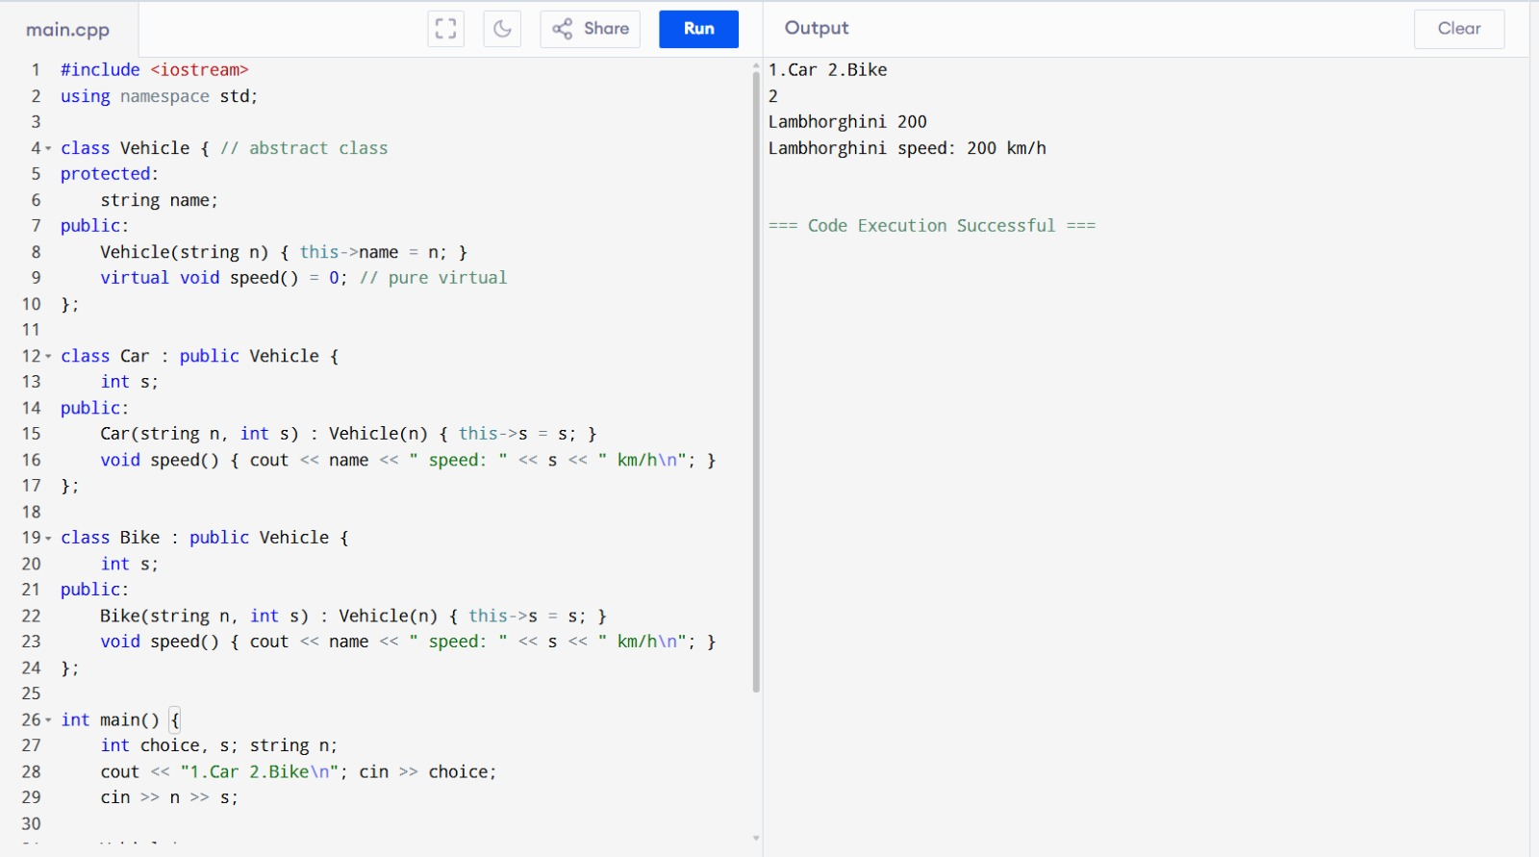
#include <iostream>
using namespace std;

// Abstract class
class Shape {
protected:
int value;

public:
Shape(int v) {
this->value = v; // this pointer
}

virtual void area() = 0; // pure virtual → abstract class
};

class Square : public Shape {
public:
Square(int v) : Shape(v) {}

void area() override {
cout << "Area of Square: " << value * value << endl;
}
};

int main() {
Shape* s; // base class pointer (dynamic binding)
Square sq(4);

s = &sq;
s->area(); // calls derived class function

return 0;
}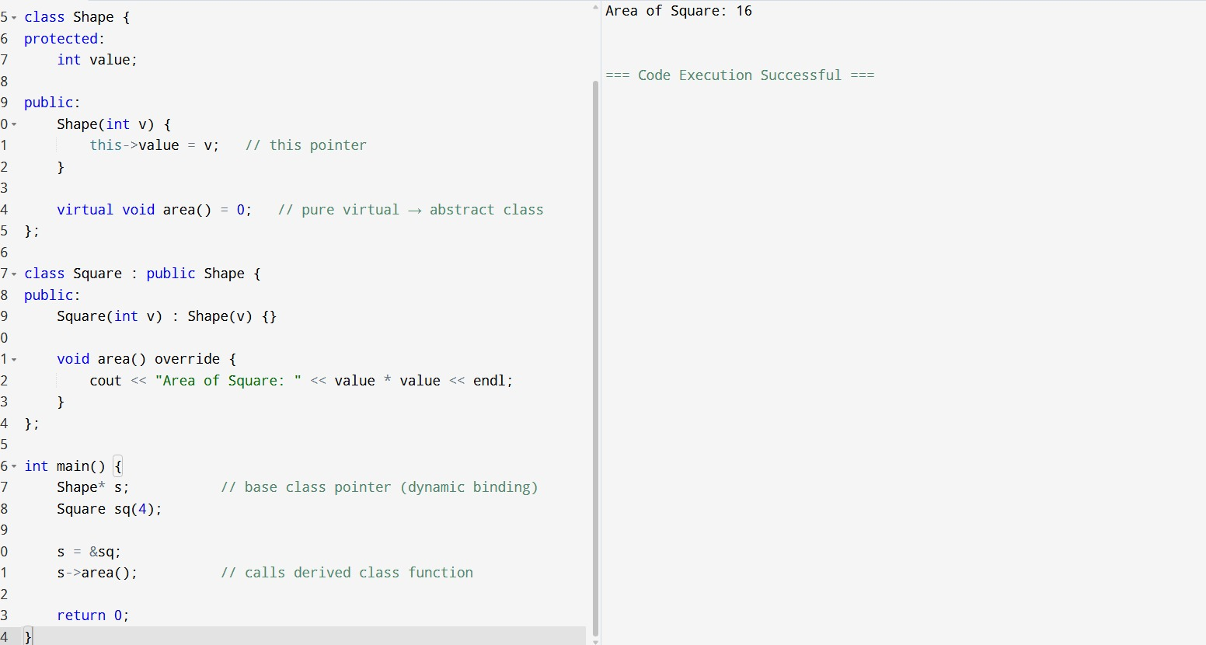

#include <iostream>
using namespace std;

// Abstract class
class BankAccount {
protected:
double balance;

public:
BankAccount(double b) {
this->balance = b; // this pointer
}

virtual void calculateInterest() = 0; // pure virtual
};

class SavingsAccount : public BankAccount {
public:
SavingsAccount(double b) : BankAccount(b) {}

void calculateInterest() override {
cout << "Interest: " << balance * 0.05 << endl;
}
};

int main() {
BankAccount* acc; // dynamic binding
SavingsAccount s(1000);

acc = &s;
acc->calculateInterest(); // calls derived class function

return 0;
}
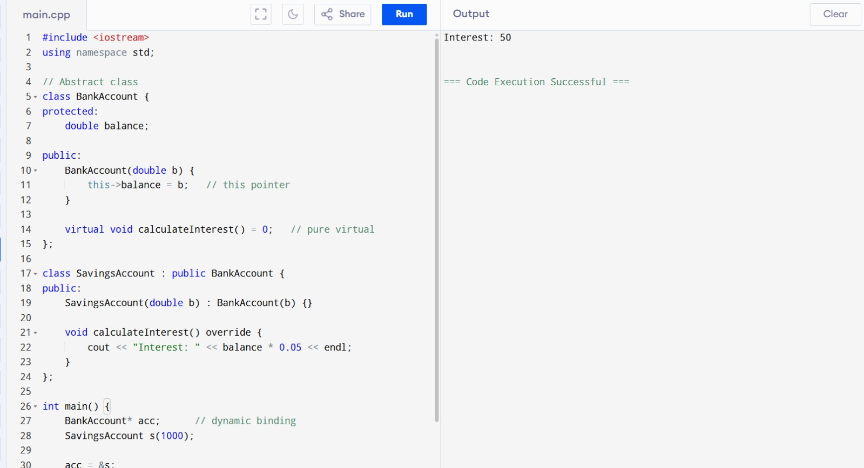

#include <iostream>
using namespace std;

// Abstract class
class Payment {
protected:
double amount;

public:
Payment(double a) {
this->amount = a; // this pointer
}

virtual void pay() = 0; // pure virtual → abstract class
};

class UPI : public Payment {
public:
UPI(double a) : Payment(a) {}

void pay() override {
cout << "Paid using UPI: " << amount << endl;
}
};

int main() {
Payment* p; // dynamic binding
UPI u(500);

p = &u;
p->pay(); // calls derived class function

return 0;
}
